Serious Cyber Security: Building Games to Educate University Students about Security

CO600 Technical Report

Conor Finn (CF338), Alice Jaffray (AJ418)

Supervised by

Dr Jason Nurse (J.R.C.Nurse@kent.ac.uk)

University of Kent

# Abstract

Gamification and serious games are progressively being used over a whole host of fields and this includes education. ‘SherLOCKED’ is a serious game, that was created in the style of a 2D top-down puzzle adventure. The main purpose of this game is to consolidate the learnings of undergraduate students about cybersecurity. Its creation was finalized after a review of existing serious games and a study of common gamification principles.

# 1. Introduction

## 1.1 Serious Cyber Security: Building Games to Educate University Students about Security

The public’s reliance on electronic devices and cloud services to complete work effectively is only likely to rise further (around 26% of files in the cloud contain sensitive data (McAfee, 2020)). As a result, there has been a strong push to motivate the next generation of cyber security experts. Allowing them to help to manage the risks that come with relying on these devices and services. This push can be observed in the UK government’s “Cyber First” scheme (NCSC, 2020); designed to attract young people into the industry. With such a high demand for cyber security knowledge, improving the enjoyment and teaching methods of cyber security modules would be a strong benefit to the entire industry.

In this report, we describe the design, implementation and evaluation of a game that is aimed to consolidate the learnings from lectures of students on the ‘Computer Security and Cryptography’ module at UKC. The game is a puzzle adventure with a 2D top-down style. It follows the storyline of a detective, helping a victim of hacking. The aim of the game is to beat the hacker. It requires players to answer questions on a range of topics from lectures about cyber security, to advance through levels, competing for new high scores and achievements. The aim was to explore and evaluate gamification principles and their value to increase engagement with the module contents and use these for our own game. We will test the effectiveness of the principles by examining the knowledge of cyber security of the participants. The game is designed to focus more on reinforcing knowledge that has been gained during the more conventional lectures. By providing questions in an interesting setting and within context, the hope is that recalling the knowledge becomes easier; assisting the students in answering both examination and interview questions. The plan is to conduct testing and analysis into the effectiveness of the game by sending it out to students of the module during lectures and get their feedback of the game using a feedback form.

# 2. Background

## 2.1 Serious Games

Use of the term “serious game” can be traced back to the renaissance. However, the first use of the phrase where it has the same meaning to what it means today, can be found in a book, “Serious Games”, by Clark Abt (1970). He discusses the use of games to improve education and training. Also giving a more concrete definition of what serious games actually are: “These games have an explicit and carefully thought-out educational purpose and are not intended to be played primarily for amusement. This does not mean that serious games are not, or should not be, entertaining.” (Abt, 1970). While the actual definition of serious games has changed across the years, they almost always follow this template for their creation. Serious games are applicable for education in a very wide range of areas including health (such as for the treatment of ADHD (FDA, 2020)), military training and recruitment (America’s Army (U.S Army, 2020)), and education, as we shall discuss in this report.

## 2.2 Gamification

University lecturers are increasingly using some form of gamification during lectures as a form of motivation and consolidation for students. At a university, it was found that 32% of lecturers were using a version of gamification in lectures and of the lecturers that were not, 92% stated they were most likely to use it in the near future (Karmela Aleksic-Maslac, 2017). University students, particularly engineering students, are afraid to feel ashamed by participating in lectures by asking questions or giving the wrong answers to questions. Therefore, the use of gamification in a lecture allows students to engage in their courses without the impact of real-world human relationships. (Asako Ohno, 2013).

## 2.3 Existing Solutions

Gamification has been used in education to great effect in the past. One such example is the study done to the Vienna University of Technology (Dabrowski, et al., 2014). In this paper, the entire course structure was adapted into a gamified version. In addition to ordinary lectures that would still be attended, students were expected to complete a range of “challenges”. These challenges were designed to fit into a “movie style” hacking environment to make the experience of completing the challenges more entertaining, and potentially easier to remember. The study also took advantage of the progress reporting and competition gamification techniques by providing a leader board for students on the course. The study also made use of achievements and badges, also a well-known gamification technique, to motivate students to do well. The study found that 96% of the students that took the course enjoyed the “gaming-like aspects” of the practical exercise. 57% also responded that gamification of topics would help to encourage students to take cyber security modules and courses.

Another study at Leeds Beckett University (Schreuders & Butterfield, 2016) which used gamification as a method to improve motivation for completing learning tasks beyond assignments. The methodology involved the creation of three kinds of experience points (XP), with each focusing on a different element of the course: practical skills, knowledge, and reflection. Tasks to be completed were given XP values and were framed as “quests”. Students were also given access to an online tool that allowed them to track the amount of each XP they had accrued at the year progressed. All students responded that they liked having access to their progress at any time, with 63% liking seeing their relative XP compared to other students. All students taking part in the course also said that they did more out of class work than they would have done otherwise.

Research conducted at the Delft University of Technology (Iosup & Epema, 2014) involved the use of a points system to motivate students to complete additional activities. Grades within the course are determined based on the number of points achieved while the course is running. The results show a 10% increase in the number of students that completed the course and found that 50-75% of the students in each class felt better motivated by gamification methods.

# 3. Requirements

## 3.1 Method

To establish our requirements, we first deliberated on what we wanted our game to accomplish, to consolidate the learnings of undergraduate students of cyber security. After this, we considered how we would achieve this within our game throughout both the retainment and engagement of the players. We then cultivated our requirements grounded off research conducted into existing studies of gamification principles and cybersecurity.

## 3.2 Questions

The in-game questions are directly mapped to lectures students on the Cyber security module will partake in. The topics range from cyber security, risk management and usable security. We created these questions by reading through four lectures given to us by Dr Jason Nurse, he teaches half the cyber security module. Each level is based on one of his lectures, and they are in chronological order i.e. level 1 is centred around lecture 1. The questions are written to follow the storyline of the game and with the theme of the detective asking himself these questions. These topics were covered to help undergraduate students reinforce their learnings from cyber security lectures.

### 3.2.1 Case 1 - Security Properties

### For level 1, we created questions from the first lecture. We focused on the CIA triad and definitions of keywords associated with computer and cyber security.

### 3.2.2 Case 2 - Security Services and Attacks

### The questions for level 2 were created from the second lecture. They are centred on security services, security attacks and their types. We also included questions themed on attacker types and why we need security. There are questions to consolidate the learnings of keywords in this lecture.

### 3.2.3 Case 3 - Risk Management

### For level 3, we formed questions from the third lecture. The questions are about security risk definitions and the security risk management lifecycle. We also test the player on the function to calculate security risk as well as some keyword definitions.

### 3.2.4 Case 4 - Usable Security

Finally, level 4 is based on the fourth lecture. This lecture and thus our questions focus on usable security, including what it is and guidelines for it. We wrote questions asking users about usability features and the problems of usability security. There are questions based on evaluation techniques also.

## 3.3 Gameplay

The gameplay ought to adhere to gamification principles (see section 4.3) to keep the players both engaged in the game and to help the players retain the knowledge learnt during the game. From the beginning, we decided that a clear theme and strong narrative were going to be the most important gamification principles to our game as we wanted it to be both aesthetically pleasing and engaging for all players. “Thomas Malone describes video games enjoyment as stemming from the levels of challenge, curiosity and fantasy” (Aponte, et al., 2011). In SherLOCKED we would have to avoid the gameplay norm that each level has to progressively become harder. This is because, regardless of the player’s skill level, they should be able to get through all of the levels. In addition, “the level of challenge is directly related to the game’s difficulty” (Maria-Virginia Aponte, 2011) therefore we needed to keep the challenge level of the game steady whilst not letting the enjoyment of the game suffer. The difficulty here is that “the player may feel bored if the task is too easy, or anxious if it’s too hard” (Maria-Virginia Aponte, 2011) to prevent this, each level has the same style questions but, the topics change. This test the knowledge of different topics, so the player won’t become either bored or anxious.

# 4. Design & Implementation

## 4.1 The Game

SherLOCKED is a multi-level, top-down 2D detective themed game, which involves the player navigating through a house. The player controls the movement of the detective and, as they move around each level, they have to find the questions attached to objects randomly in each room and answer them.

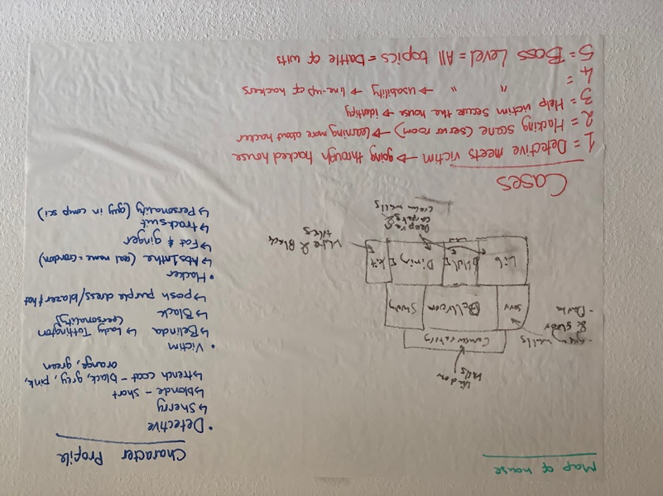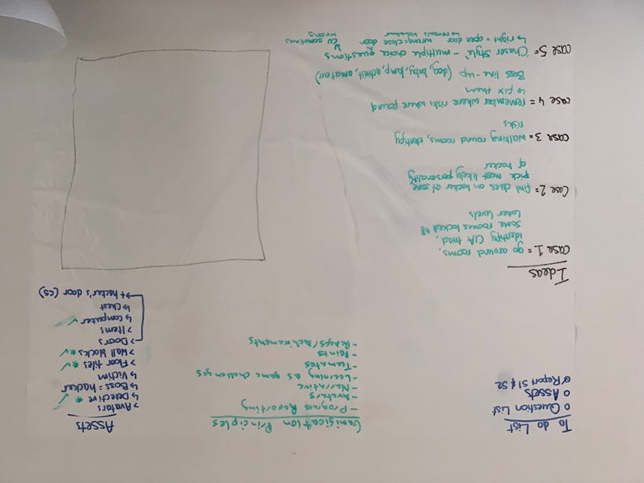

Figure 1 - Planning pages for the project

Initial planning for the project was on whiteboards to develop an understanding of the basics. We created mock-ups of the map we would be using for the game’s cases (Fig 1), alongside the content that would be covered by each of the cases. The planned cases were driven by our requirements, with the effort being made to ensure that any plans adhered to the gamification principles we would be following. Each of the different levels would take place on the same map, but more rooms would become available and with different clues to find in each one. This process of planning the rooms, assets, characters, and cases that we would be creating ensured that we knew what we had to work on next at any given time.

The game was made using the Unity game engine as it’s good for cross-platform development and for creating multiplatform games and has useful features such as Tile Palettes (Fig 2), which makes it easier to create Scenes.

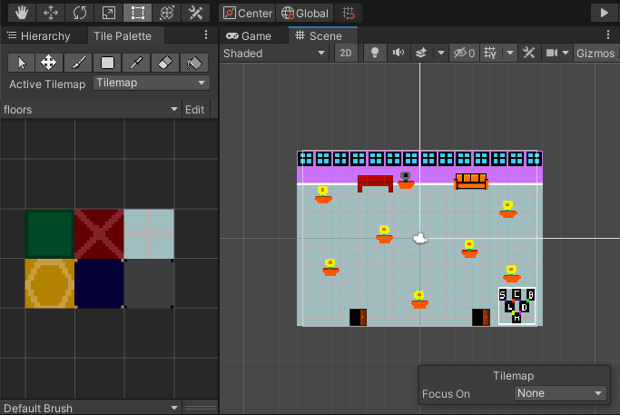

Figure 2 – Conservatory room being created using the ‘floors’ Tile Palette we created

Another reason for choosing Unity is its ability to export games to a WebGL format that can run from a browser. This allowed us to upload the game to a service called simmer.io, where Unity games can be played online[1]. Therefore, the game is much easier to access and use, so it becomes a more versatile learning tool.

The basis of each level (‘case’) is to go around the rooms that are unlocked, finding questions to answer (Fig 3).

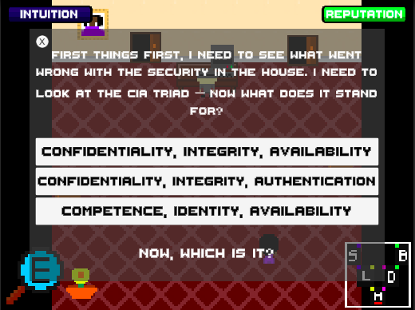

Figure 3 – Example question in case 1

If the question is answered correctly then the player will be presented with praise and they will gain intuition points (Fig 4).

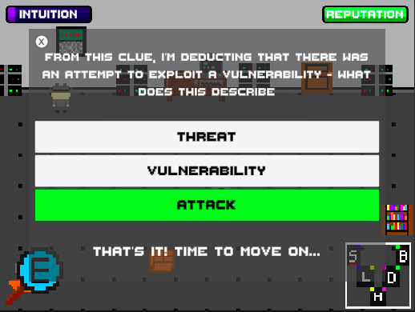

Figure 4 – Correct answer with praise & intuition points given in case 2

If the question is answered incorrectly then the player will be presented with positive feedback and they will lose reputation points (Fig 5).

## 

Figure 5 – Incorrect answer with positive feedback & reputation points lost in case 3

As players work their way through rooms answering questions, their progress (intuition & reputation) bars will adjust depending on the player’s score. If the player answers enough questions correctly, they will gain a full intuition bar and will win the level. If the player answers too many questions incorrectly, they will lose all their reputation points (indicated by the bar) and will lose the level. When a case has been solved, the player returns to the Case Select menu (Fig 6), and the case number they have solved will turn green. At the start of the game, all the case numbers will be red; the player will work through the game in the hopes to solve all the cases.

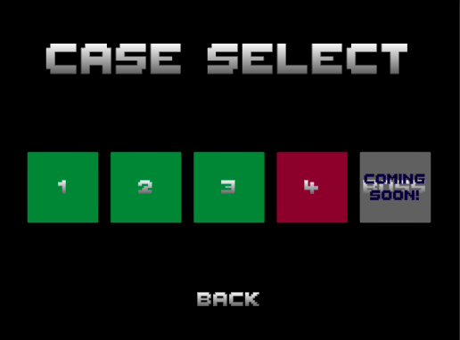

Figure 6 – Case Select menu where cases 1,2 & 3 have been solved

## 4.2 Taxonomy of SherLOCKED

A taxonomy for serious games was outlined to have 5 criteria (Laamarti, et al., 2014)(see Appendix A) and we designed SherLOCKED respecting this. The first criterium is the Application Area; this defines which domain the game is most relevant to. Our game’s application area is education. The second one is the Activity criteria; the most applicable choice was mental, as the game is going to involve educating through the answering of questions about cyber security. The next criterium is the modality of the game. This indicates how “information is communicated from computer to human participant” (Laamarti, et al., 2014). The sensory modality that applies most to SherLOCKED is visuals because we can permit players to read the questions and feedback at their own pace. Additionally, we can make it visually appealing. Furthermore, there is an auditory modality through the background of the game, “which helps increase players motivation” (Laamarti, et al., 2014). The interaction style criterium is about how the user will control the game; we chose it to be through the keyboard (e.g. arrow keys) because the target platforms include Windows and Mac. The fifth and final criteria we looked at was the environment; we decided on a 2D design. This was because we wanted to create a simple yet appealing game whilst focussing on the gamification principles.

## 4.3 Gamification Principles

We have chosen to use gamification principle from the gamification periodic table (see Appendix B) (Marczewski, 2020) as it helped us to think of different aspects of the game that we could focus on in terms of gamification principles. For each one we have chosen to use we will explain how we have chosen to implement it in our game and how it will benefit the game and the player’s experience.

### 4.3.1 Theme

One of our first decisions when designing the game was the theme it would be based around. One study, (Scholefield & Shepherd, 2019) explored the use of gamification principles to educate users about password security. The participants were over the age of 18, which is the same target graphic for our game (university students). Participants commented on their theme, medieval RPG, “The characters were fun to look at, was like playing an RPG” and “I enjoyed the character animations” (Scholefield & Shepherd, 2019). We have decided on a detective theme, (see section 4.3.5 for the narrative) with an animated detective as the character and levels being called cases. A theme will help to motivate students and add enjoyment to their learning.

### 4.3.2 Onboarding

Onboarding is a crucial gamification principle as it’s the process of introducing a player into the game. We have to ensure the onboarding is engaging and easily understood as to ensure players want to stay focused and continue playing the game (Petersen, et al., 2017). To introduce the characters, features and premise of the game we show a conversation between Sherry and Ginny (Fig 7). The use of animations makes it appealing to the player.

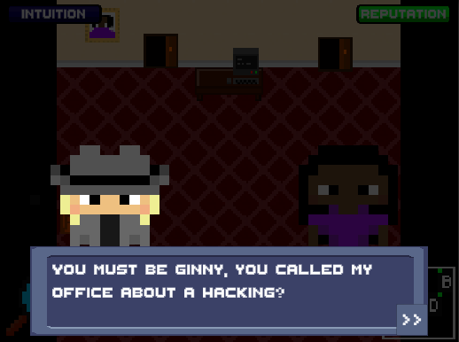

Figure 7 – Conversation screen between Ginny and Sherry

### 4.3.3 Feedback

Feedback is essential in an educational game as it prevents people from being confused about the current task and text-based feedback is seen as a more direct and appropriate way of communicating (Scholefield & Shepherd, 2019). Therefore, when a player answers a question they are always provided with feedback. If they get the question correct, they are told they were correct and the answer button they selected will turn green. If they get the question wrong, they are told they were wrong. The answer button they selected will be red and the correct answer button will be green. This answer feedback is aimed to be constructive to aid learning. When they answer a question, they cannot answer the question again. One study found that positive feedback was more effective than negative feedback when repair could not be made (Welbers, et al., 2019). So, we give positive feedback when a question is answered incorrectly, such as “Nearly!” and a suggestion for what they need to revise before playing the level again (Fig 5).

### 4.3.4 Progress Reporting

Studies have found that progress reporting is a great gamification principle to motivate students (Barata, et al., 2013). In the game, there are two progress bars, reputation and intuition. At the beginning of each level, the intuition bar is empty, and the reputation bar is full. When a question is answered incorrectly, they lose reputation points (Fig 5) and when a question is answered correctly, they gain intuition points (Fig 4). If all reputation points are lost, the level is over, and the player is taken back to the level/case select page where they have to redo case 1 until they complete it successfully. If all intuition points are gained, the player is taken back to the level/case select page, where they can see that the case has been completed.

### 4.3.5 Narrative

A narrative is an important part of the game to us. We want players to fully immerse themselves in the game to enhance their learning in a fun and new environment. If we assume that players stop playing when they’re not enjoying themselves, producing player enjoyment should be a top priority when creating a game (Sweetser & Wyeth, 2005). The storyline follows a detective named Sherry, who is the character the users play, helping a victim of hacking (cyberstalking), named Ginny. The hacker is called, Abs1nthe and is introduced later on in the game. The narrative is told through the questions asked in the game.

In the first case, the detective meets the victim and they will go through the hacked house looking for clues. A clue is a question on cyber security that the player must answer. However, some rooms are locked. In the second case, the detective is in the previously locked server room. They go around that room learning more about the hacker, answering questions. At the end of the case, the player must pick out the most likely personality of the hacker, from the clues they have gathered. In the third case, the detective is walking around the house helping identify how to secure the house from the risk of future hacking attacks; answering questions on identifying risks. In the fourth case, the player has to remember where the risks were found and fix them; answering questions to fix a risk. At the end of the case, the player must pick the hacker out of a line-up. The final case is a boss level, the detective goes head-to-head with the hacker (computer) answering all the questions they’ve had to answer through the cases. It’s a battle of wits. The hacker is behind a closed door. If the player gets a question right, the door opens by a certain amount but if they get it wrong the closes by a certain amount. When the door is completely open, the hacker is revealed, and the player has won.

### 4.3.6 Customisation

Customisation instils a sense of ownership for the player. When they are able to customise their character, they gain investment and emotional tie to the game (Peter K, 2017). In our game, customisation comes in the form of being able to choose the colour of the detective’s hat and trench coat. The option is given to the player at the beginning of the game (Fig 8).

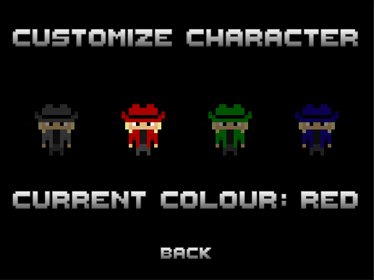

Figure 8 – Customisation Menu for Sherry

### 4.3.7 Competition

Competition allows players “a chance to prove themselves against others” (Marczewski, 2020). In SherLOCKED, when a player finishes a level, they will be presented with their score (number of questions they answered correctly) and the time they took to complete a level (Fig 9). This can be used to create a leader board or players can compare scores, which creates competition between players and will drive players to achieve better scores within the game.

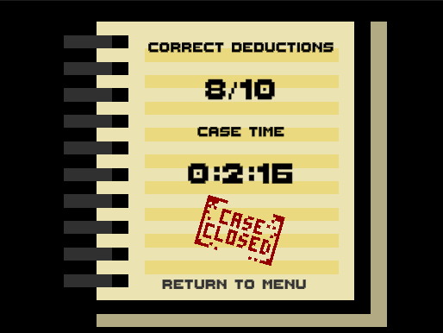

Figure 9 – End of case screen (this case has been passed)

### 4.3.8 Signposting

“Even the best people need to be pointed in the right direction” (Marczewski, 2020). We interpreted this gamification principle with the use of a MiniMap. A MiniMap will be used to represent the house layout and, a red line will indicate to the player the room they are in currently (can be seen in Fig 3). This principle gives players a sense of comfort that they know where they are in the house. Also, it may intrigue them as it shows rooms that are currently locked. Therefore, it may motivate them to reach levels where these rooms are unlocked.

# 5. User Study and User Evaluation

## 5.1 User Acceptance Testing

### On 22nd February 2021, we undertook user acceptance testing in a Cyber security (CO634/CO558) LecSem (lecture support session). We began by introducing our project; we then shared a link to a Google Form. This included a consent form, questions to answer before playing our game, a link to our game on Simmer.io and questions to answer after playing our game. We got 112 responses to our feedback form (see Appendix C); we will discuss the highlights of these responses.

### 5.1.1 Data collected

### From the feedback forms, we collected plenty of useful data (see Appendix C).

The main aim of the game was to educate the students on the CO634/CO558 module. Therefore, we asked the students to rate their confidence in each topic we covered in the game; on a scale of 1-5, with 5 being very confident and 1 being not confident.

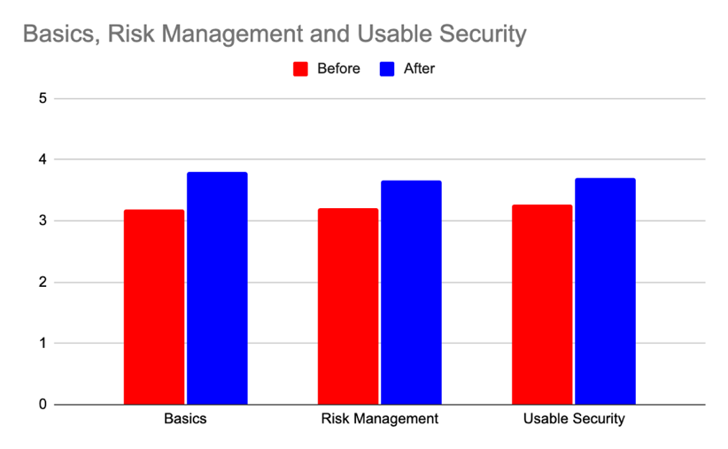

Figure 10 – A bar graph showing the average answers given of confidence in each topic before and after playing the game

From this graph (Fig 10), you can see that our game helped improve the confidence of students in every topic covered in the game. We also asked which of our gamification principles the participants found the most important when playing a game. This question gained varied responses (Fig 11). The three largest portions of data were competition, a strong narrative and feedback on actions. This is advantageous as a strong narrative and feedback are key elements of our game.

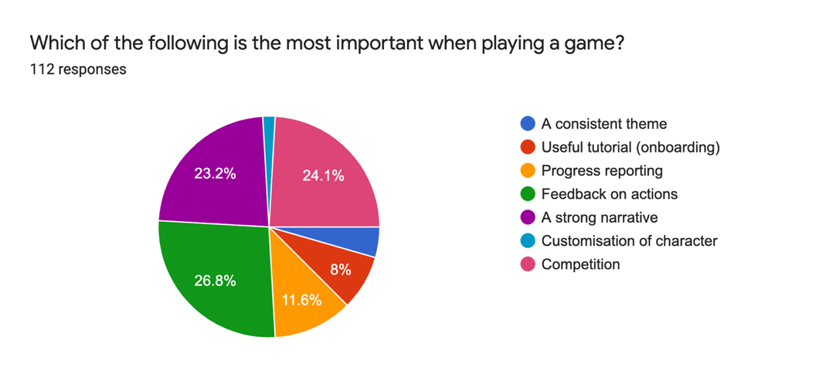

Figure 11 – Pie chart showing which gamification principle participants found important when playing a game.

Other useful data collected include 87.5% (98) of participants stated that the game helped improve their understanding of lecture material. Furthermore, 84.8% (95) of participants said playing ‘Serious Games’ in lectures would help them to learn and, 65.2% (73) of participants would come back to SherLOCKED to help revise for the exam. These large percentages gave us confidence in our game and its ability to help undergraduate students.

### 5.1.1 Positive feedback

In the feedback form, when we asked participants what they liked most about the game, we have selected the average answers given. Overall, the participants enjoyed the simplicity and ‘retro’ feel of our game. One participant stated the games was “more engaging than reading notes” and that it “reinforced knowledge that I had, helped to show areas that I was unsure about”.

##### 5.1.1.1 The Questions & Answers

The participants enjoyed the questions and multiple choice answers we wrote. One participant stated, “The questions in the cases were relevant to cyber security and pushed me to think”. They also said that we had achieved the right level of difficulty of questions, “Good difficulty of questions”. Generally, SherLOCKED has “Interactive and challenging questions”. Additionally, the multiple-choice answers we wrote were also highlighted in the positive feedback. One participant wrote that it was “helpful where some of the definitions are similar and makes you think about which is the right one”. Conversely, someone else said that “I like how sometimes the answer is obvious as other options are hilarious. It helps me when I’m unsure about the answer and acts as a revision.”. Another key point given was the “instant feedback after answering questions” was a useful element of our game. We are pleased with this feedback as this was built to be an educational game, hence, the questions were the main element of the game, so for them to be one of the main chunks of the positive feedback is excellent.

##### 5.1.1.2 The Graphics

##### Many participants commented on how they liked the graphics, with some answering what they liked most about the game with “the graphics”. The simplicity in their answers matched the “simplicity in artwork and design” of our game. This was an important piece of feedback for us as we set out to achieve an aesthetically pleasing game.

##### 5.1.1.3 The Theme

The final piece of positive feedback was the theme. Many participants commented on how they liked our “retro theme” and how “the game captured the detective vibe”. The feedback shows we had achieved the gamification principle of giving our game a theme as well as making it enjoyable for the player and aesthetically pleasing.

### 5.1.2 Critical feedback

In the feedback form, we asked participants what they liked least about our game and, we have collated the average answers given into the following categories. We also asked if they found any bugs in our game and, no significant bugs were found.

##### 5.1.2.1 Settings Menu

A significant portion of the critical feedback asked for a “music option to turn it down” or a “way to mute” the music. However, in the positive feedback, a few comments were saying the “music was good”. We have concluded that although our music choices were good, the player should have the option to turn down or off the music in a settings menu.

##### 5.1.2.3 Arbitrary Gameplay

Another piece of critical feedback given was about our gameplay being arbitrary and "quite repetitive". One participant stated, “the gameplay was quite boring, being just walk to object, interact, answer quiz, go to next object, with not much reward (apart from not losing)”. This links to another participant comments on how it "would be cool with gold coins to collect". We agree with these comments and, we would improve on this by adding different question styles e.g. drag and drop complete the diagram question.

##### 5.1.2.4 Clue Counter

The final piece of critical feedback was that it would be useful to know how many clues there were left to find as it was “difficult to find the final few clues – maybe a checklist to show how many left to find”. Also, “it wasn’t immediately obvious there were multiple deductions per room, I had assumed there was one per room and spent some time wondering how to get through the closed doors.”. Due to having a date when we had to do user testing, we needed to test our game at an appropriate time in the module. We, unfortunately, were not able to include all the elements in the game that we wanted to. One of these was a clue counter to show how many clues there were left to find e.g. 2/10, 2 being the number of clues you had found and 10 being the total amount of clues to find in the level.

## 5.2 Discussion and Reflection

Overall, we agree with and are pleased with all the feedback we received. Not only did the positive feedback highlight all the points we planned our game to achieve, but it also opened our eyes to areas where our game which needs work. In the future, using what we learnt in our user study, we would hope to improve on the game. We would mainly like to adjust our game accordingly to the critical feedback from the user study. We would add a music section to our settings menu so that players could choose to mute the background music or, using a slider, to change the volume of the music. Although the participants enjoyed the music, they would like the option to turn it down or off (see section 5.1.2.1). We would also add a clue counter to the top of the game screen, along with the progress bars, so that players knew what they had left to do to complete a case (see section 5.1.2.4). In addition, we would want to adapt the gameplay by adding new types of questions (see section 5.1.2.3) and adding rewards, like badges. We would increase the narrative throughout the levels by adding a hacker line up between cases like we had planned (see section 4.3.5) because we got so much positive feedback about the narrative. Finally, we would like to finish the game with the boss level we had planned (see section 4.3.5).

# 6. Conclusion

In conclusion, we built the game SherLOCKED, which used gamification principles; with a researched taxonomy of serious games to educate the students enrolled on the cybersecurity module (CO634/CO558). We carried out a user study with the students enrolled on the module in 2020/2021. Through this study, we saw students engage with the module content and increase their confidence in it. We have proved that gamification can successfully be used in a university setting to educate students. There is a lack of published work into the effects of gamification used in lectures. Therefore, we believe that using SherLOCKED in place of a cybersecurity lecture would be a great opportunity to further research in this field. We could also further test our game and help students increase their confidence before exams.

# 8. Acknowledgements

We wish to thank Dr Jason Nurse for introducing us to gamification principles and cybersecurity and encouraging us to deliver and maximise our potential in this project.

# 9. References

Abt, C. C., 1970. *Serious Games.* 4 ed. s.l.:Viking Press.

Aponte, M., Levieux, G. & Natkin, S., 2011. *Difficulty in Video Games : An Experimental Validation of a Formal Definition.* Lisbon, ACM International Conference Proceeding Series. 49.

Barata, G., Gama, S., Jorge, J. & Gonçalves, D., 2013. Engaging Engineering Students with Gamification. *ResearchGate*, January.

Dabrowski, A. et al., 2014. *Leveraging Competitive Gamification for Sustainable Fun and Profit in Security Education,* Vienna: SBA Research, Vienna, Austria; Vienna University of Technology.

FDA, 2020. *Press Annoucements: FDA.* [Online]   
Available at: https://www.fda.gov/news-events/press-announcements/fda-permits-marketing-first-game-based-digital-therapeutic-improve-attention-function-children-adhd

Iosup, A. & Epema, D., 2014. *An experience report on using gamification in technical higher education.* s.l., Proceedings of the 45th ACM technical symposium on Computer science education.

Laamarti, F., Eid, M. & El Saddik, A., 2014. An Overview of Serious Games. *International Journal of Computer Games Technology,* 2014(358152).

Marczewski, A., 2020. *Gamified UK.* [Online]   
Available at: https://www.gamified.uk/user-types/gamification-mechanics-elements/  
[Accessed 16 02 2021].

McAfee, 2020. *Enterprise Supernova: The Data Dispersion Cloud Adoption and Risk Report,* s.l.: s.n.

NCSC, 2020. *Education and Skills: National Cyber Security Centre.* [Online]   
Available at: https://www.ncsc.gov.uk/section/education-skills/11-19-year-olds#section_1

Peter K, 2017. *UX Planet.* [Online]   
Available at: https://uxplanet.org/gamification-in-2017-top-5-key-principles-cef948254dad  
[Accessed 19 01 2021].

Petersen, F., Thomsen, L., Mirza-Babaei, P. & Drachen, A., 2017. *Evaluating the Onboarding Phase of Free-toPlay Mobile Games: A Mixed-Method Approach.* s.l., s.n.

Scholefield, S. & Shepherd, L., 2019. *Gamification Techniques for Raising Cyber Security Awareness,* Dundee: Springer.

Schreuders, Z. & Butterfield, E., 2016. *Gamification for teaching and learning computer security in higher education,* s.l.: USENIX.

Sweetser, P. & Wyeth, P., 2005. GameFlow: a model for evaluating player enjoyment in games. *Computers in Entertainment,* 3(July 2005), p. 3.

U.S Army, 2020. *America's Army.* [Online]   
Available at: https://www.americasarmy.com/

Welbers, K. et al., 2019. Gamification as a tool for engaging student learning: A field experiment with a gamified app. *E-Learning and Digital Media,* 16(2), pp. 92-109.

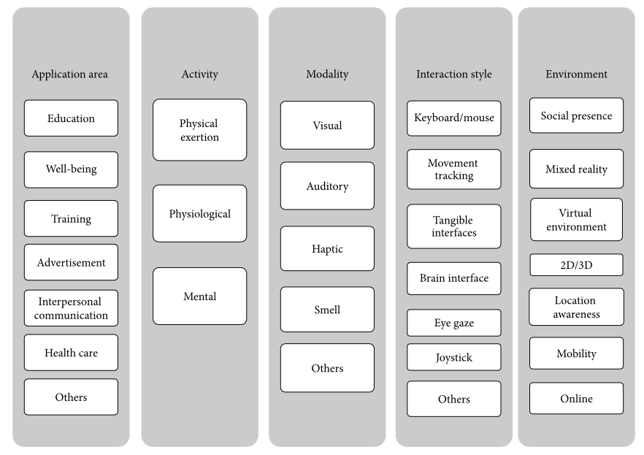10. Appendices

Appendix A - Taxonomy of a serious game (Laamarti, et al., 2014)

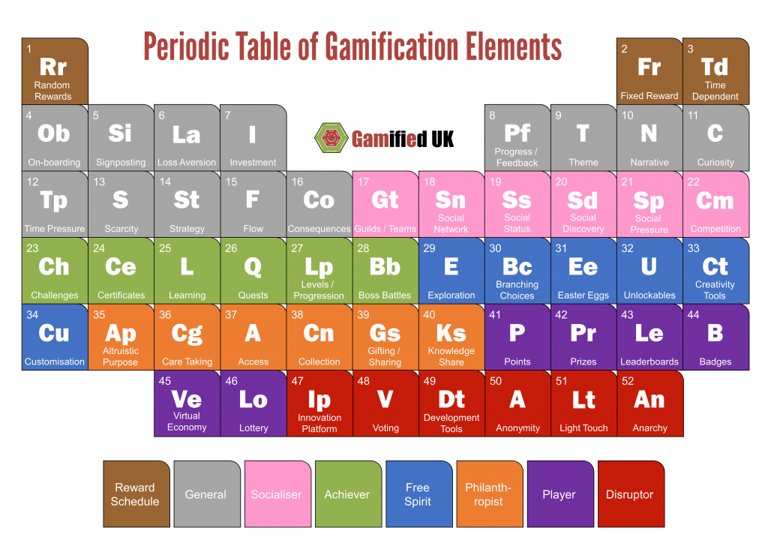

Appendix B – Periodic table of gamification elements (Marczewski, 2020)

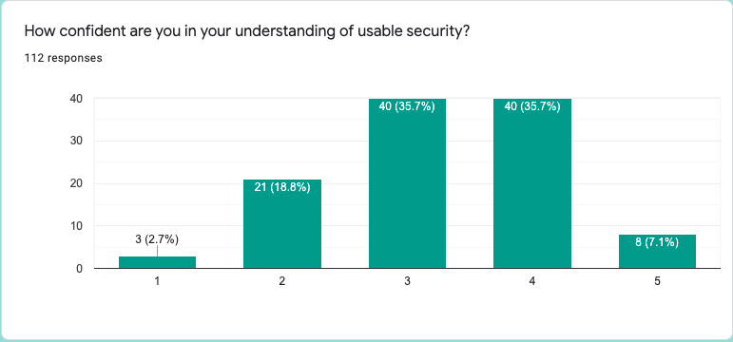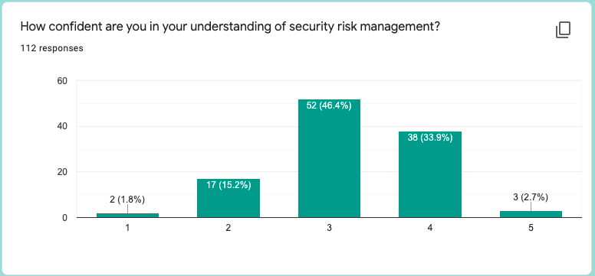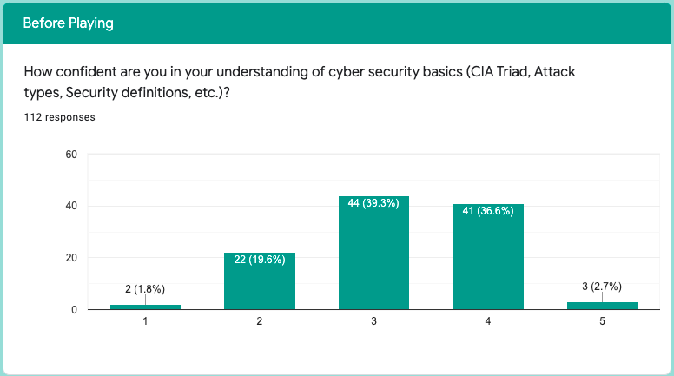

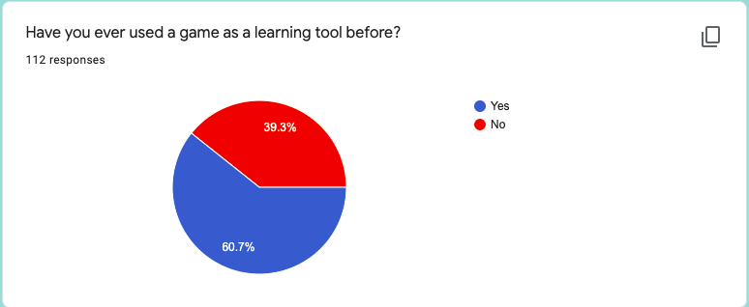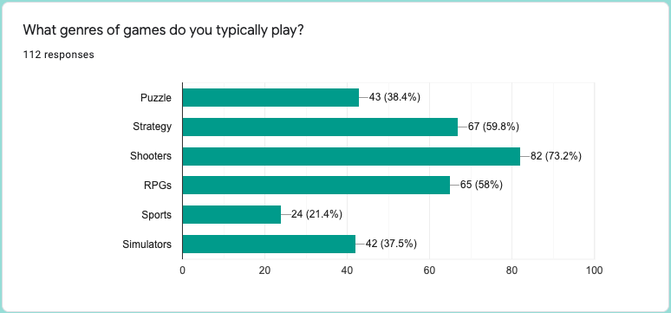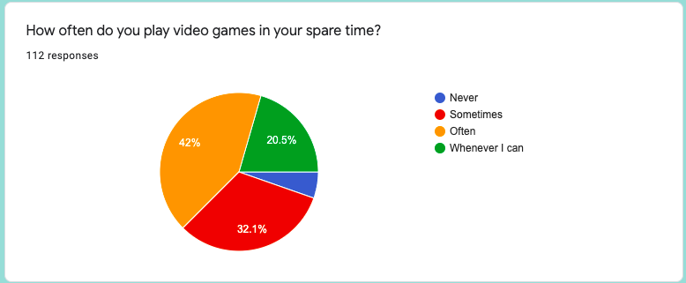

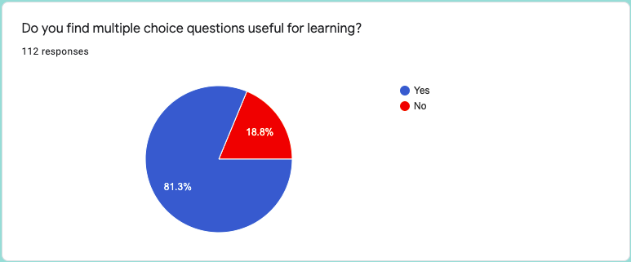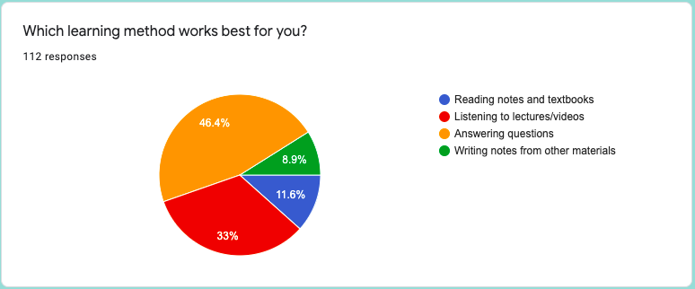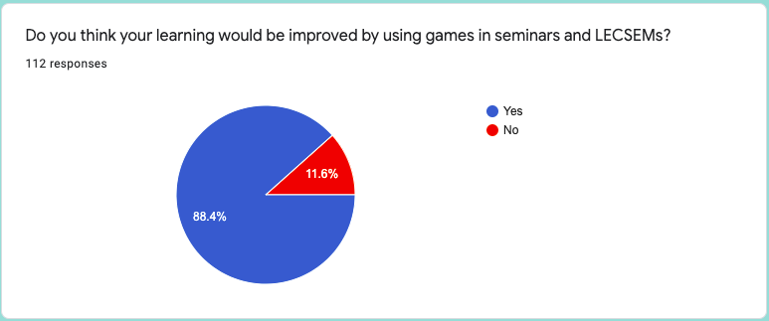

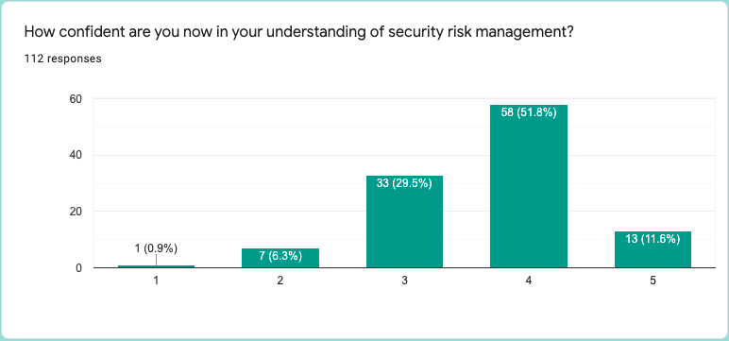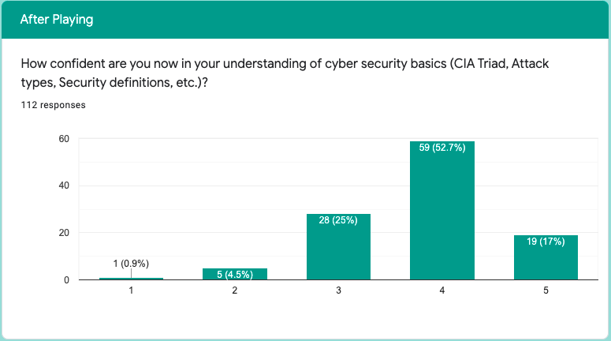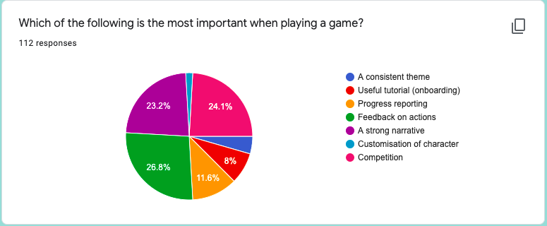

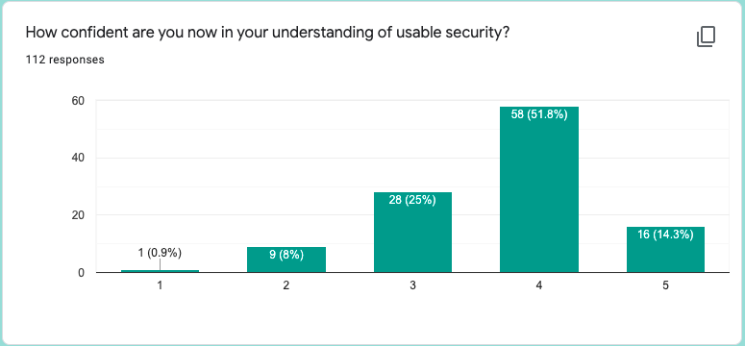

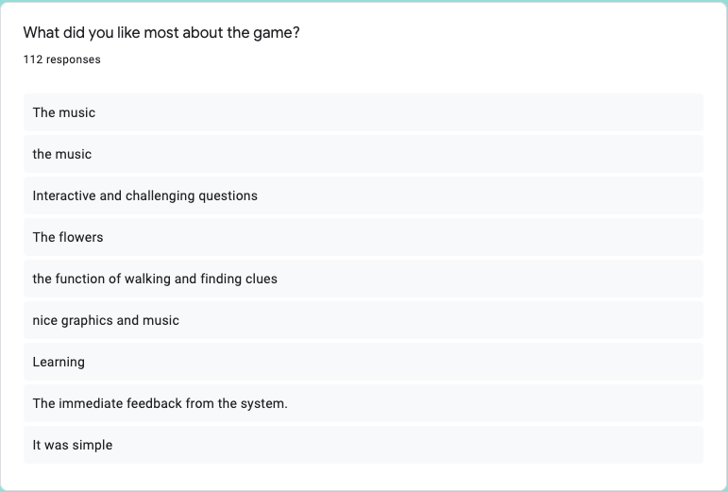

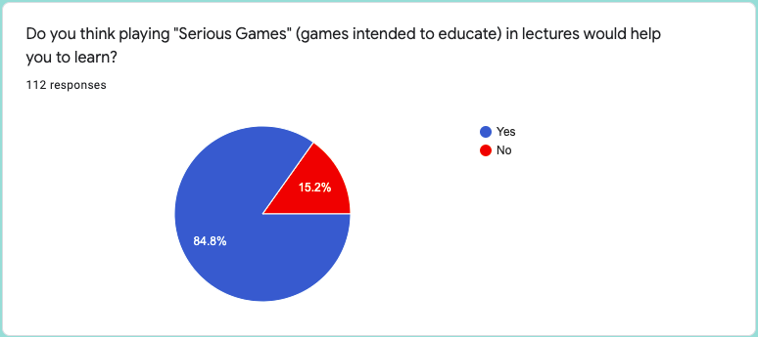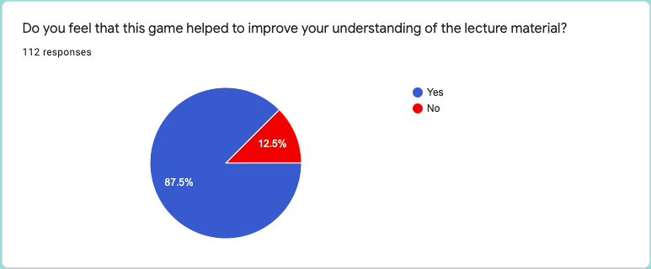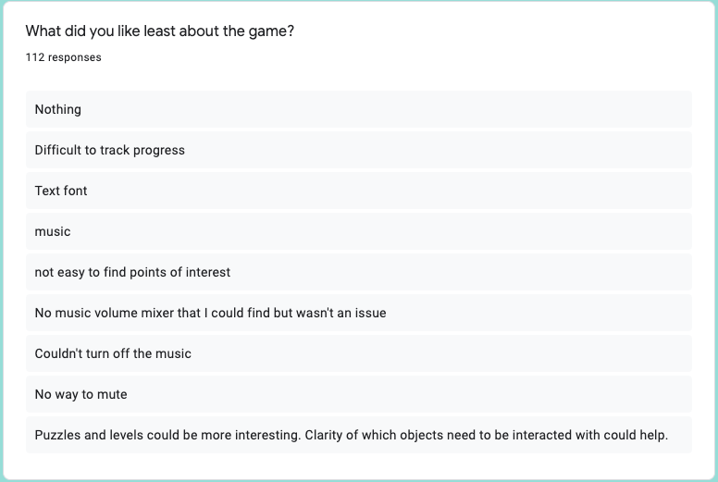

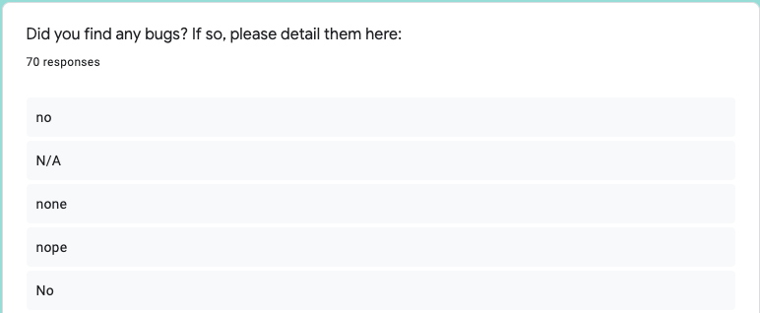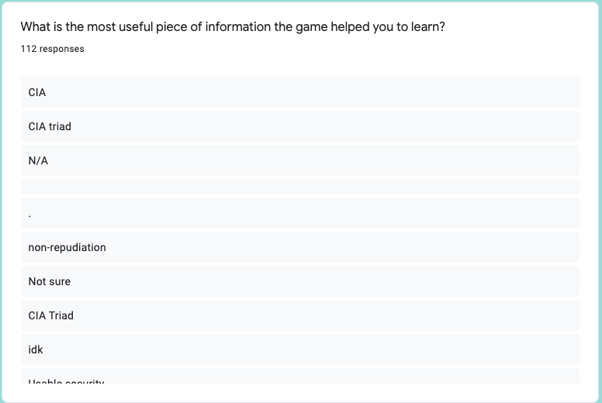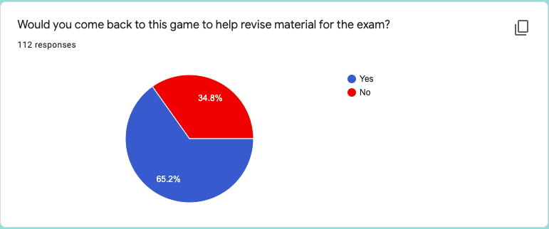Appendix C – Responses given in user study

1. Sherlocked is available to play at: https://simmer.io/@ConorFinn/sherlocked